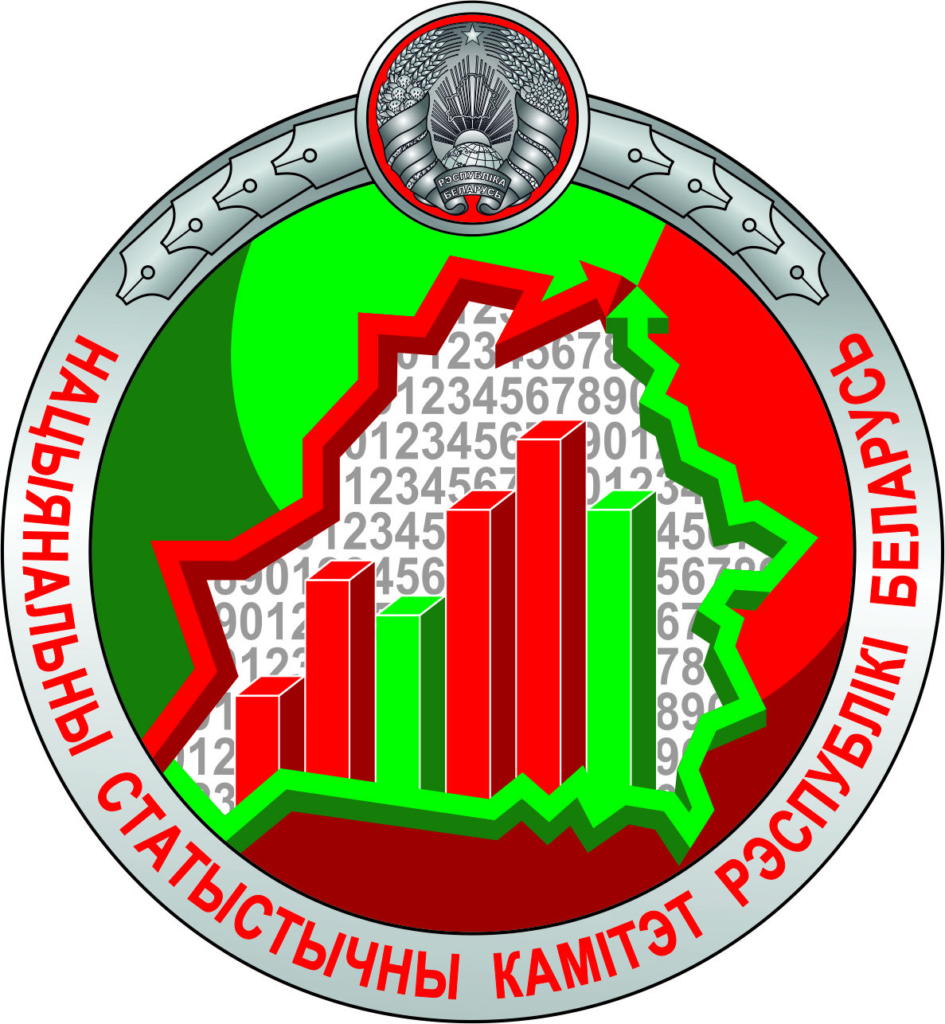
NATIONAL STATISTICAL COMMITTEE OF THE REPUBLIC OF BELARUS

INDUSTRY OF THE REPUBLIC OF BELARUS

Statistical booklet

MINSK

2025

EDITORIAL BOARD:

Inna Medvedeva – Chair of the Editorial Board
Tsimafei Zhyharau, Zhanna Vasilevskaya, Aliaksei Yarkavets, Natallia Tarasiuk,
Aksana Liatko, Elena Kondratenko, Elena Palkovskaya, Tatiana Silich

The statistical booklet is an annual publication that provides brief official statistical information on the most important indicators of industry development, such as the dynamics of industrial production, fixed assets and investment in industry, labour, small and medium business in industry, financial performance of industry organisations.
The 2023 data on some statistical indicators have been revised compared with the previously published data; data for 2024 are provisional and may be revised in further issues.
Information by economic activity is based on the National Classification of the Republic of Belarus ОКРБ 005-2011 “Kinds of Economic Activity”.
A brief glossary of statistical terms is available on the official website of Belstat at https://www.belstat.gov.by/metodologia/kratkiyglossariy-statisticheskikh-terminov/ (in Russian).
Methodologies of compilation and calculation of statistical indicators are available on the official website of Belstat at https://www.belstat.gov.by/metodologiya/metodiki-po-formirovaniyu-i-raschetu-statistichesk/ (in Russian).

Abbreviations: |  | Explanation of symbols:
руб. – Belarusian ruble |  | – | not applicable
долл. США – United States dollar |  | … | data not available
тыс. – thousand |  | x | filling in the data is impossible
млн. – million |  |  | or impractical
млрд. – billion

ISBN 978–985–7343–16–4 | © National Statistical Сommittee of the Republic of Belarus, 2025  E-mail: belstat@.belstat.gov.by  http://www.belstat.gov.by  © State Committee on Property of the Republic of Belarus, 2025

CONTENTS

1. | Brief Methodological Notes | 5
2. | Visually about industry of the Republic of Belarus | 8
3. | Key economic indicators of industry development | 12
3.1. | Main indicators of industry performance | 12
3.2. | Selected indicators of Goal 9 “Build resilient infrastructure, promote inclusive  and sustainable industrialization and foster innovation” of the National list  of the Sustainable Development Goal Indicators | 14
3.3. | Structure of manufacturing gross value added by level of technological intensity | 14
3.4. | Structure of production and sales costs of products (works, services) in industry organisations | 15
3.5. | Concentration of industrial production by economic activity in 2024 | 16
3.6. | Volume of industrial production per capita by districts and cities of regional subordination in 2024 (map) | 17
3.7. | Fixed assets of industry organisations | 18
3.8. | Technological structure of fixed capital investment in industry | 18
3.9. | Structure of fixed capital investment in industry, by source of financing | 18
3.10. | Indicators of innovation activity of industry organisations | 19
4. | Main indicators of industry by economic activity | 20
4.1. | Mining and quarrying | 20
4.1.1. | Main indicators | 20
4.1.2. | Share of regions and Minsk City in the volume of production in 2024 | 20
4.2. | Manufacturing | 21
4.2.1. | Main indicators | 21
4.2.2. | Share of regions and Minsk City in the volume of production in 2024 | 21
4.3. | Electricity, gas, steam, hot water and air conditioning supply | 22
4.3.1. | Main indicators | 22
4.3.2. | Share of regions and Minsk City in the volume of production in 2024 | 22
4.4. | Water supply; collection, treatment and disposal of waste, remediation activities | 23
4.4.1. | Main indicators | 23
4.4.2. | Share of regions and Minsk City in the volume of production in 2024 | 23
5. | Main indicators of industry by regions and Minsk City | 24
5.1. | Brest region | 24
5.2. | Vitebsk region | 25
5.3. | Gomel region | 26
5.4. | Grodno region | 27
5.5. | Minsk City | 28
5.6. | Minsk region | 29
5.7. | Mogilev region | 30

