Share of FEZ residents in the main macroeconomic indicators of the Republic of Belarus
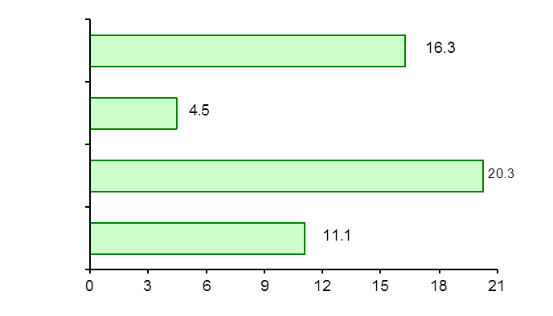
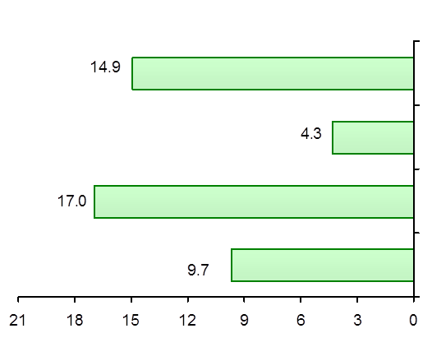
(percent)
January - September 2019 January - September 2020

Industrial output
Fixed capital investment
Exports of goods

Imports of goods

